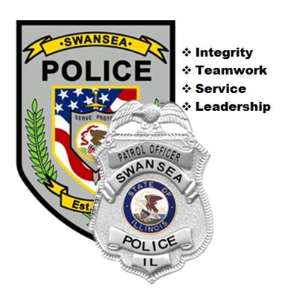
2024
Annual Report
Swansea
Police Department

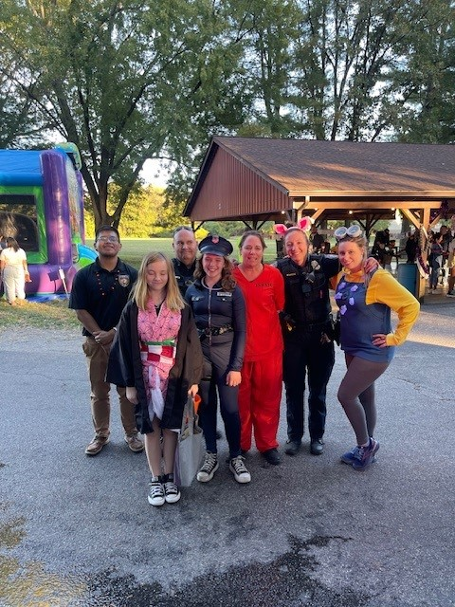

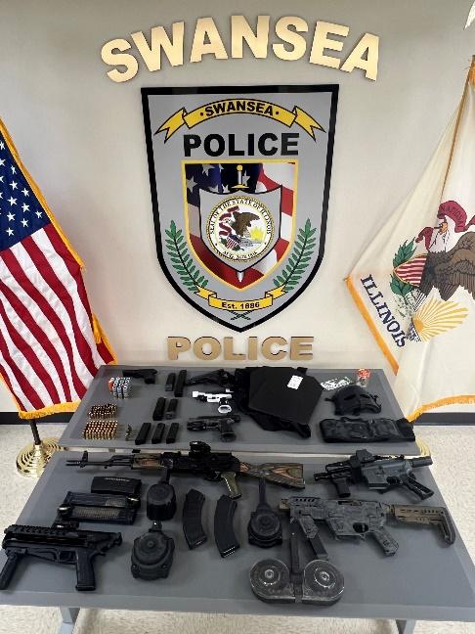
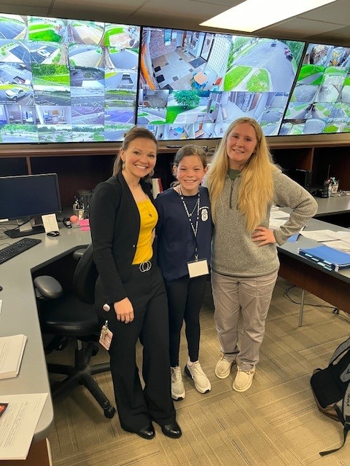

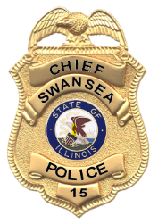
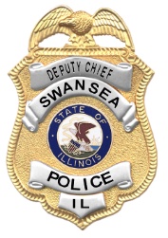
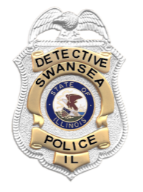
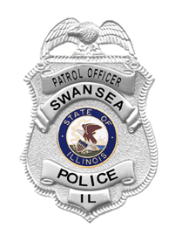
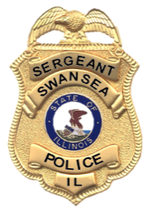
Table of Contents
Letter from the Chief 3
Vision, Mission, and Values 4
Personnel 5
Awards 6
Patrol Squad One 7
Patrol Squad Two 8
Patrol Squad Three 9
Patrol Squad Four 9
Criminal Investigations Unit 11
Drug Tactical Unit 12
Major Case Squad 13
School Resource Officer 13
Civilian Police Aides 14
Youth Academy 14
Evidence 15
New Equipment 16
Drone Team 16
Training 17
Active Shooter Program 18
Charitable Efforts 19
Internship Program 19
Social Media 20
Website & Police Blotter 21
Hyper-Reach Program 21
Swansea Cultural Working Group 21
Index Crimes 22
Offense Summary Report 2024 24
Swansea Police Department
Chief Matthew T. Blomberg
1400 North Illinois Street
Swansea, IL 62226
618-233-8114
mblomberg@SwanseaIL.org
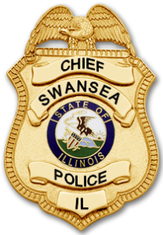
- Integrity
- Teamwork
- Service
- Leadership

Dear Swansea Community Member,
The Swansea Police Department had a highly productive and rewarding year in 2024. Our dedicated officers responded to nearly 29,000 calls for service throughout the year. To ensure their ongoing professional development, the department collectively completed over 1,500 hours of in-service training, fulfilling state certification requirements and advancing specialized skills.
Located at the intersection of two major Illinois highways, our officers prioritized traffic safety while consistently engaging with and serving the community. Several individuals within the department were recognized for their exceptional contributions during the year. Officer Lindley was named 2024 Officer of the Year by his peers and received commendations from the Illinois Licensed Beverage Association, SILEC, and SIPCA for his pivotal role in a significant illegal firearms case in March. Officers Lindley, Hewitt, and Schackmann were also honored with Aggressive Criminal Enforcement (ACE) awards for their exemplary work in self-initiated efforts related to firearms, drug enforcement, and fugitive apprehension.
Sgt. Kemper-Damm earned the Leadership Award from the Illinois Law Enforcement Training and Standards Board Executive Institute at the annual Women in Criminal Justice conference in Peoria, IL, recognizing her outstanding leadership. The Investigations Unit was awarded a Unit Citation of Excellence for its exemplary teamwork and dedication in managing a high volume of complex cases.
Deputy Chief Keith Howard furthered his professional development by attending the prestigious FBI National Academy Session 292 in Quantico, VA, where he received executive training in leadership, emerging trends, and collaboration with law enforcement agencies at all levels.
School Resource Officer Marquis Jones made a significant impact during his first year at High Mount School and Wolf Branch School, forging meaningful relationships with students and staff. His mentorship will have a lasting effect on those he served, and his leadership as Camp Director at the annual Swansea Police & Fire Youth Academy was outstanding.
The department also completed a long-awaited remodel of the locker rooms, enhancing officer facilities with modern amenities and additional space for future personnel. Upgrades to technology and infrastructure within the station further support our officers' ability to perform their duties effectively and efficiently.
As we reflect on the accomplishments of 2024, we look forward to another successful year in 2025, continuing to serve and protect the Swansea community with pride and professionalism.
- Chief Matthew Blomberg
Our Vision, Mission, and Core Values
To set the standard in law enforcement through leadership, innovation, and commitment to excellence in everything we do.

“Serve as a guardian with honor and protect with vigilance.”
We shall carry out the vision and mission statements while utilizing the following core values as our guiding principles.

INTEGRITY
We shall demonstrate the courage to do what is right, putting honesty, a sense of duty, and sound moral principles at the forefront of our decision-making.

TEAMWORK
We shall be extremely committed and highly motivated to combine our energy and expertise to achieve excellence through collaborative partnerships.

SERVICE
We shall demonstrate dignity and respect for all regardless of circumstance, model conduct beyond reproach, and exemplify the utmost standards of personal appearance.

LEADERSHIP
We shall inspire, empower, develop, and support one another and citizens to reach our fullest potential, both individually and organizationally, in order to achieve strategic community goals.

ACCOUNTABILITY
We shall individually and organizationally demonstrate the ownership necessary for achieving desired results by making sound personal choices through empowerment.

Departmental Personnel
Patrol Officer Start Date
Chief Matthew T. Blomberg 01/08/1999
Deputy Chief Keith E. Howard 09/17/2007
Sgt. Peter A. Wszalek 09/09/2004
Sgt. Breanna M. Kemper-Damm 09/25/2014
Sgt. Braxton Kociemba 02/18/2020
Sgt. Erin Huff 09/08/2020
Det. Sgt. Gary W. Reuter 10/11/2016
Det. Jason M. Frank 07/25/2005
Det. Alex G. Wilken 02/21/2018
Officer Eric A. Rohn 06/07/2000
Officer Paul J. Wuller 01/06/2005
Officer Jason C. Tutterow 01/06/2005

VILLAGE OF SWANSEA

Mayor
Mike Leopold

Trustees
Matt Lanter
Cary Lewis V
Brian Thouvenot
Rocky McDonald
Marilyn Neumeyer
Jeff Parker

Administrator
Ben Schloesser

Clerk
Tyler Thompson

Treasurer
John Walter
Officer Andrew C. Hewitt 01/22/2013
Officer Matt R. Lindley 11/18/2013
Officer Daniel M. Voelker 09/22/2014
Officer Justin E. Schutzbach 01/12/2015
Officer Darrell D. Dunn 09/14/2021
Officer Seth Belford 03/07/2022
Officer Marquis Jones 03/07/2022
Officer Claire Dappen 05/02/2022
Officer Derrick Acheampong 03/20/2023
Officer Clayton Proffitt 04/17/2023
Officer Derek Schackmann 11/20/2023

Civilian Personnel
Supervisor Ashley J. Robbins 04/30/2012
CPA Danyel J. Bagby 06/21/2017
CPA Nickolas Thouvenot 09/05/2018
CPA Hannah Bielke 09/12/2022
CPA Myesha Fisher 11/07/2022
CPA John Lynch 10/31/2023
CPA Alexis Eagan 07/29/2024
Awards
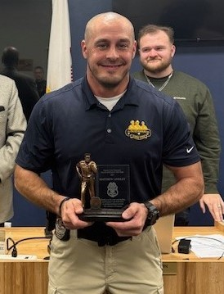
Officer Matt Lindley received the Swansea Police Officer of the Year Award for 2024. Nominations for the award were submitted to a selection committee comprised of fellow officers and Deputy Chief Howard. After deliberations, the committee unanimously selected Officer Lindley as a result of his exceptional enforcement efforts during the year for the award. Officer Lindley steadfastly served his oath to serve the public while protecting our community. He was extremely proactive in criminal enforcement while handling his service calls and investigations with professionalism, commitment, and thoroughness. His efforts last year resulted in him earning another ACE Award for Aggressive Criminal Enforcement efforts in which he made 115 self-initiated felony arrests. In March, Officer Lindley made a significant felony arrest involving a large number of illegal guns and ammunition, which resulted in him receiving recognition from the Southwestern Illinois Law Enforcement Commission and Southern Illinois Police Chiefs Association as well as the Illinois Licensed Beverage Association. In addition to his patrol duties, Officer Lindley served extensively as the Officer in Charge for his squad throughout the year. This is Officer Lindley’s 4th Officer of the Year award in the past 5 years. Outstanding work Officer Lindley! Village Administration, the Police Department, and our community truly appreciate you!
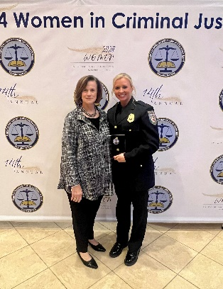
Sgt. Breanna Kemper-Damm received the 2024 Women in Law Enforcement Leadership Award from the Illinois Law Enforcement Training and Standards Board Executive Institute for efforts in developing our department’s Officer Wellness Program and establishing our partnership with We Never Walk Alone, an organization committed to providing mental health services to first responders. Additionally, she collaborated with Anew Perspectives in Maryville, IL to provide mental health and counseling services to our staff and their families. The award also commended her for her efforts in developing our Special Needs Locator Program for families with loved ones with cognitive disorders who may need law enforcement assistance. Congratulations Sgt. Kemper-Damm!
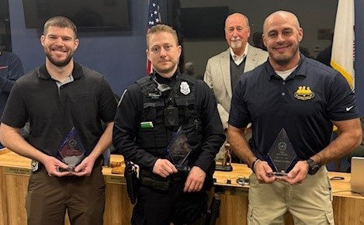
Officers Derek Schackmann, Andrew Hewitt, and Matt Lindley received ACE (Aggressive Criminal Enforcement) awards for their efforts in 2024. The award requires an officer to make a minimum of 10 self-initiated felony arrests relating to drug and/or firearms offenses or felony fugitive apprehensions during the year. Officers Hewitt and Schackmann made 13 such arrests, and Officer Lindley made an incredible 115 arrests.
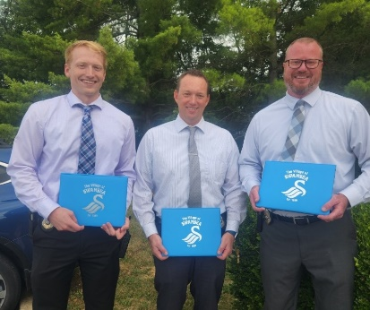
The Investigations Unit received a Unit Citation of Excellence in 2024 for their outstanding teamwork, resilience, and integrity while executing their duties through unwavering dedication, exemplary professionalism, and commitment to upholding the highest standards of justice. The Unit consists of Alex Wilken, Gary Reuter, and Jason Frank. Thank you, detectives, for the incredible work you do!
- Chief Matt Blomberg

Patrol Division
Patrol Squad One
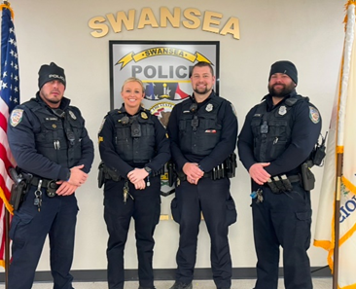
In 2024, Patrol Squad #1 consisted of Officer Matthew Lindley, Sgt. Breanna Kemper-Damm, Officer Daniel Voelker, and Officer Justin Schutzbach.
Officer Lindley continued with his dedication to traffic enforcement, which yielded the recovery of several firearms and drug-related arrests, not to mention one of the most monumental traffic stops of his career to date. Officer Lindley initiated a traffic stop before the St. Patrick’s Day Parade in downtown Belleville. As a result of the traffic stop, the driver was arrested and subsequently charged with six Class X Felonies. Officer Lindley, without a doubt, saved countless lives that day. When Officer Lindley isn’t initiating traffic stops, resulting in felony arrests, he can be found training new hires through our Field Training Officer program and conducting in-house training for high-risk traffic stops. It is through his training and experience that he can pass along his knowledge and expertise.
Officer Voelker continued with his dedication to service within our Village. Officer Voelker continues to provide quality service to victims. I have witnessed firsthand how Officer Voelker shows such care and empathy for victims of severe crimes against persons. His calming nature allows victims to feel safe and heard. When Officer Voelker is not handling calls for service, he can be found training new hires through our Field Training Officer Program, conducting in-house Taser training, as well as firearm range training and qualifications. Over the past year, Officer Voelker continued to provide active shooter response training to local businesses, of which I received positive reviews. It is through Officer Voelker’s hard work and commitment that he started our first-ever Swansea FOP Lodge #500 Golf Outing, which will be held in May 2025.
Officer Schutzbach continued with his dedication to assisting and serving within our Village. Officer Schutzbach returned with years of tactical experience, which proved beneficial when assisting detectives with executing search warrants. When Officer Schutzbach isn’t conducting his patrols, he can be found training new hires through our Field Training Officer program and utilizing his training and experience as a Drone Pilot. Through his pilot school, Officer Schutzbach has provided a significant amount of assistance in several high-priority cases, including missing persons. It is with his knowledge and experience that we have been successful with the drone program.
Officers Lindley, Voelker, and Schutzbach serve the Village of Swansea with great pride. The services they provide in their profession are incalculable. I know I can always count on Officers Lindley, Voelker, and Schutzbach to bring a positive outlook to our shift. I know each of them brings something different to the squad, and that is what makes them so special. We work together to accomplish the end goal of serving our Village. Without these three officers, we would not have been so successful this past year. I am looking forward to the opportunity to work alongside this amazing crew again next year!

- Sgt. Breanna Kemper-Damm

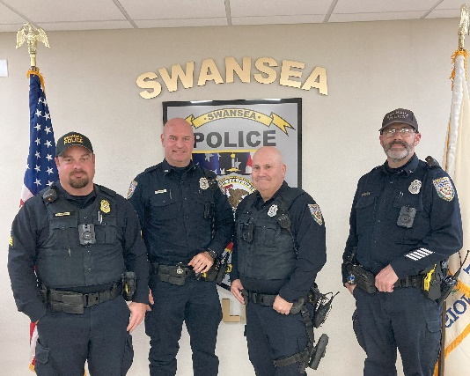
Patrol Squad Two
In 2024, Squad #2 worked the day shift from 6 a.m. to 6 p.m. and was made up of Officer Eric Rohn, Officer Paul Wuller, Officer Jason Tutterow, and Sergeant Peter Wszalek Jr.
Officer Rohn is the department’s most senior patrolman. Officer Rohn is a consummate professional and offers great guidance and leadership to younger officers.
Officer Wuller has been with the Swansea Police Department for over 19 years. Officer Wuller is diligent in his report writing and an asset on every call for service with great knowledge and calmness.
Officer Tutterow, who was previously assigned as the School Resource Officer (SRO), rejoined the patrol ranks. Officer Tutterow is a steady and diligent influence for officers and residents alike.
The members of Squad #2 professionally and purposefully serve the residents of Swansea.

- Sgt. Pete Wszalek

Patrol Squad Three
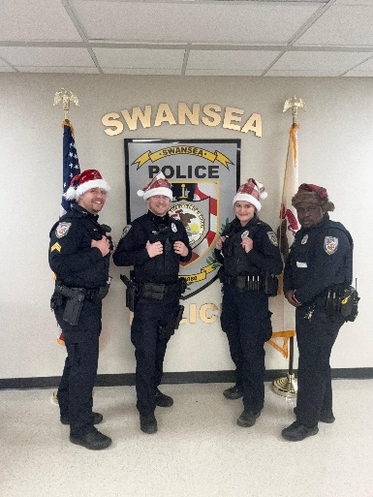
During 2024, Patrol Squad #3 consisted of Officers Andrew Hewitt, Claire Avila, Derrick Acheampong, and Sergeant Braxton Kociemba. Squad #3 worked the night shift from 6 pm to 6 am.
Officer Hewitt returned to the night shift from a previous assignment and brought with him 11-plus years of law enforcement experience. Officer Hewitt conducted numerous traffic stops that led to several felony arrests for drugs and firearms. Officer Hewitt is also one of our certified field training officers (FTO) and assisted in training our most recent new hire at the beginning of the year.
Officer Avila remained on Squad 3 from 2023. Officer Avila has continued to grow with our department and set an example by leading the department in DUI arrests for 2024. Officer Avila’s rigorous work ethic and attention to detail go above and beyond the call of duty.
Officer Acheampong came to Squad 3 after a short year with Squad 2. Officer Acheampong always has a positive attitude and is willing to help with any task. Officer Acheampong brought several years of work experience with him from the St. Louis Metropolitan Police Department. Officer Acheampong has quickly adapted and become a great asset to the Squad.
I am proud of Squad #3 and all we have achieved. I look forward to continuing to serve with these officers into 2025.
- Sgt. Braxton Kociemba

Patrol Squad Four
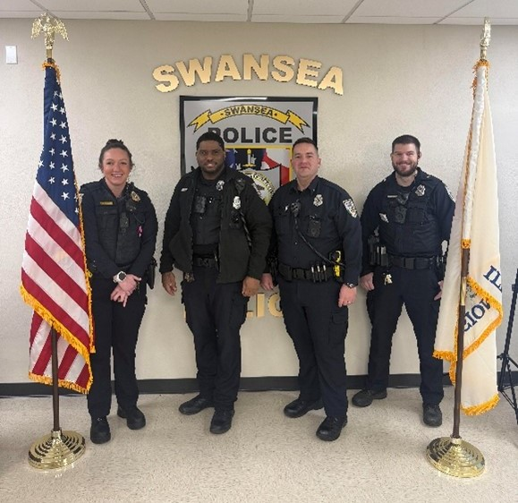
In 2024, Patrol Squad Four consisted of Officer Darrell Dunn, Officer Clayton Proffitt, Officer Derek Schackmann, and myself, Sergeant Erin Huff.
Officer Dunn completed his third year of service with the Swansea Police Department. Officer Proffitt, who joined us in 2023, completed his second year. The newest addition to the team, Officer Schackmann, joined the squad in the spring and finished his first full year with us.
Officer Dunn showed continued dedication to the citizens of Swansea by participating in community events, working extra details such as traffic enforcement through IDOT, and picking up several shifts for the MetroLink special detail. During regular shifts, Officer Dunn continued to be the standard for communicating with citizens. Officer Dunn’s ability to talk with people in varied states of duress proves his calm demeanor to be an asset in diffusing difficult situations. Additionally, Officer Dunn completed seven DUI arrests and several felony arrests for gun and drug cases. Officer Dunn completed the Advanced Roadside Impaired Driving Enforcement course and shared the information he learned with the team, making us more proficient at DUI enforcement.
Officer Proffitt continued to be a valued member of Patrol Squad Four. Officer Proffitt shows a great deal of ambition and, at the beginning of the year, stated a goal involving DUI arrests. Being committed to keeping our streets safe, Officer Proffitt completed nine DUI arrests, all of which successfully went to court and have been charged or are currently pending. In addition, Officer Proffitt planned, coordinated fundraising, managed, and participated in several Special Olympics events. His dedication allowed the PD to make several donations to the program and netted what I suspect is the largest turnout we have had for the Special Olympics Torch Run, getting officers, their families, and our civilian staff involved. Lastly, near the end of the year, Officer Proffitt was appointed as the Senior Officer for Patrol Squad Four.
Officer Schackmann was assigned to Patrol Squad Four in the spring after completing his field training. While being new to Swansea Police, Officer Schackmann served as a St. Louis Metropolitan Police Officer for several years prior. Due to his successful career in a vastly different environment, Officer Schackmann brought a variety of skills that have proven to be very useful. This, combined with his prior service in the U.S. Marine Corps, has made him an invaluable asset to our team. Additionally, in his short time with us, Officer Schackmann successfully made fifteen self-initiated felony arrests, further proving his dedication to keeping the community safe. Beyond traffic enforcement, Officer Schackmann has proved to be hard-working and motivated.
I was lucky as a supervisor to have Officer Dunn and Officer Proffitt on my team again. Having Officer Schackmann join the squad has helped to make us a hard-working team with such a wide variety of experiences. I hope we continue to learn from each other every shift. I am both proud and thankful to have them on my team, and I look forward to seeing what they can accomplish in 2025!
- Sgt. Erin Huff
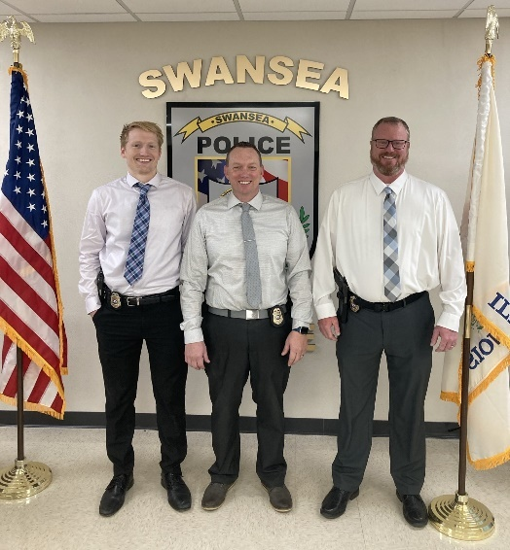
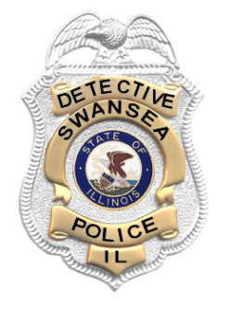
Criminal Investigations Unit
The Criminal Investigations Unit is comprised of two detectives reporting to a Detective Sergeant. Additionally, the Swansea Police Department has one investigator assigned to the St. Clair County Drug Tactical Unit (DTU). In 2024, Detective Wilken, Sgt. Reuter, Det. Frank and our DTU Investigator had 419 new cases assigned to them in addition to their ongoing investigations. Although many cases were ongoing or pending new leads, the detectives efficiently and effectively cleared a large number of the cases through hard work and diligence.
Swansea PD detectives are active members of the following task forces:
- The Major Case Squad of Greater St. Louis and Child Death Task Force
- The Illinois Crimes Against Children Task Force (ICAC)
- National Center for Missing & Exploited Children Task Force
- The United States Secret Service Cyber Crimes Investigation Task Force
- The St. Clair County Drug Tactical Unit
Detective Frank has 19 years of experience, Detective Wilken has 8 years of experience, and Det. Sgt. Reuter has 17 years of experience. Our DTU Investigator has 4 years of experience and just completed his first year assigned to the St. Clair County Drug Tactical Unit.
Detective Frank, our digital forensics expert, worked on numerous investigations and assisted numerous agencies with digital investigations and data extractions:
- Swansea PD data extractions- 32
- Other Agencies data extractions- 77
Detective Wilken is our certified Computer Voice Stress Analyzer (CVSA). Detective Wilken has assisted in several investigations utilizing this tool. Detective Wilken also investigated 9 Internet Crimes Against Children (ICAC) cases this year. Detective Wilken also serves on the Child Death Task Force.
The Investigations Unit continues to provide superior work and professionalism within our community and this region. The dedication and empathy with which they perform their duties are inspiring and admirable. As crime has evolved and become more complex, our detectives continue to learn new skills and techniques to remain at the forefront of criminal investigations.

- Det. Sgt. Gary Reuter
Drug Tactical Unit
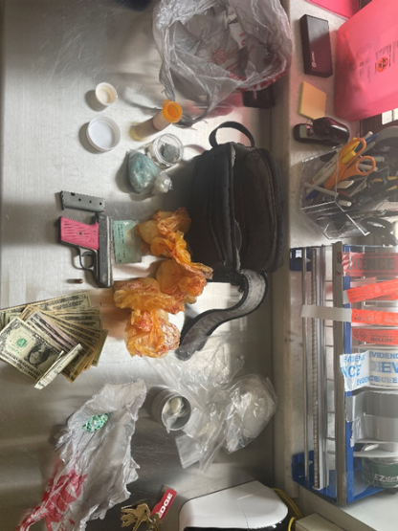
During 2024, the St. Clair County Drug Tactical Unit adopted 121 cases from the Swansea Police Department. The cases consisted of narcotics possession and drug sales along with felony weapons offenses. These cases have led to the issuing of 142 charges on arrest warrants, including 18 charges for class X felony offenses, 46 warrants for Possession of Methamphetamine, and 35 warrants for Possession of a Controlled Substance. Several of the cases are still in pending status. It should be noted that multiple cases that began from self-initiated activity were adopted by Federal agencies and charged through the U.S. Attorney’s Office.
Several of the cases that have been adopted from the Swansea Police Department have led to the identification and successful apprehension of individuals selling narcotics in the St. Clair County area, as well as additional charges through the St. Clair County State’s Attorney.
Swansea Officers seized approximately 606 grams of methamphetamine, 360 capsules of fentanyl, 47 grams of cocaine, 171 controlled pills, 1,658 grams of cannabis, firearms, 80 pills of ecstasy, 18 grams of psilocybin mushrooms, and 6 machine gun conversion devices.
One proactive arrest made by the Swansea Police Department led to the development of a confidential informant who was able to make controlled purchases from an apartment in the Village of Swansea. These controlled purchases led to the execution of a search warrant. The search warrant resulted in the seizure of cocaine and two firearms (one of which had been reported stolen). Three subjects were charged and evicted as a result of this investigation.
The majority of cases that DTU investigated for the Swansea Police Department were the result of proactive, self-initiated police work by Swansea Officers.
- Undercover Investigator

Major Case Squad of Greater St. Louis

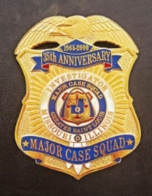
The Major Case Squad of Greater St. Louis became operational in 1965 and serves both the Missouri and Illinois Greater St. Louis area. There are currently eight counties in Illinois participating in this highly skilled and successful unit. Those counties include Madison, St. Clair, Monroe, Jersey, Macoupin, Bond, Randolph, and Clinton.
The MCS investigates the most heinous crimes, primarily homicides, but will activate for other serious crimes. An activation will typically saturate an investigation with 15-20 detectives within the first 24 hours. The MCS boasts an impressive 80% clearance rate and has been nationally and internationally recognized by the FBI National Academy and the International Homicide Investigators’ Association. Swansea detectives assisted with the following investigations:
- September St. Clair County Sheriff's Office

- Det. Sgt. Gary Reuter

School Resource Officer
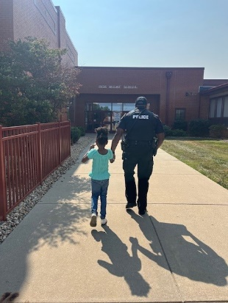
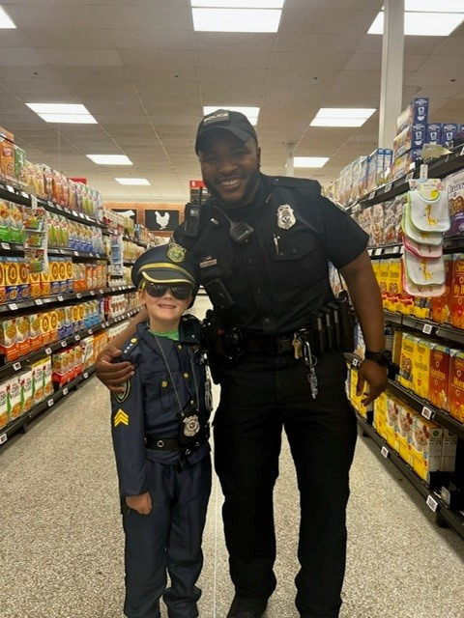
2024 was a bittersweet year for our SRO program. In January, Officer Marquis Jones served as our School Resource Officer for High Mount School and Wolf Branch School. Students and staff immediately connected with Officer Jones with his big smile and gregarious personality. He did a fantastic job building relationships with everyone associated with the schools and went above and beyond to be a positive role model to the students. Sadly, Officer Jones's time in the schools was short-lived as he made the personal decision to join the Illinois State Police. We thank him for his amazing efforts and impact on our schools and wish him the very best as an Illinois State Trooper!
- Chief Matt Blomberg

Civilian Police Aides
Many changes occurred in 2024 in the Civilian Police Aide Department, which we always welcome with open arms. Full-time CPA Nickolas Thouvenot, who also has a dual role as the evidence manager, fully implemented a barcoding system for evidence as a way to efficiently streamline property. That has been a huge success for the entire department. Hannah Bielke has continued proving to be an asset as well volunteering to assist in any way possible and learning new tasks as assigned. We would also like to thank Danyel Bagby for her dedication to this position. Danyel has been with the department since the position was created 7 years ago and her knowledge and experience are invaluable. Myesha Fisher continues to learn new skills and tasks and is currently undertaking the role of reporting to the Mid-States Organized Crime Information Center, monthly crime statistics. We were excited to add Alexis Eagan to the department. Alexis is currently attending SIUE and plans to work in law enforcement upon graduation. Arielle Stallworth accepted a 9-1-1 telecommunicator position with the Illinois State Police. In addition, John Lynch enlisted in the Marine Corps to serve his country. We wish them the best in their future endeavors. To say we are proud of the dedication, compassion, and service of our civilian staff, would be an understatement. Thank you all for what you do!

- Civilian Administrative Supervisor, Ashley J. Robbins
Youth Academy
This year’s Swansea Police and Fire Youth Academy was our 9th academy and it continued to be a successful and rewarding endeavor. Under the leadership of SRO Jones, the Youth Academy was again in high demand and as successful as ever!
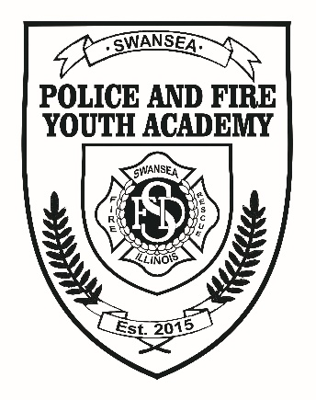
The event was held June 3-5 at Engine House #2 of the Swansea Fire Department. During the three-day academy, participants learned several aspects of the duties of first responders including police, fire, and EMS responses, techniques, and procedures. They learned how to work together through team-building exercises and by observing several demonstrations.
Some of the activities included this year were:
- Crime scene processing
- U.S. Secret Service presentation
- Simunitions and gun safety instruction
- CPR, first aid, Stop the Bleed, and stroke awareness
- FD response to a simulated car fire
- FD vehicle extrication
- Abbott Ambulance demonstration
- Air Evac helicopter demonstration
- Police K9 and therapy dog demonstrations and meet and greet
- Illinois State Police Crime Lab presentation and practical
- St. Clair County Tactical Response Team equipment demonstration
- St. Clair County Jail tour
- Grief awareness presentation, as well as the Dangers of Vaping & Drug Use
- And, of course, kickball and the inflatable obstacle course!
The Youth Academy is a wonderful, rewarding experience for the volunteers, and we hope the campers learned a lot and enjoyed themselves. We would like to thank our sponsors once again for their tremendous support:
Schnucks
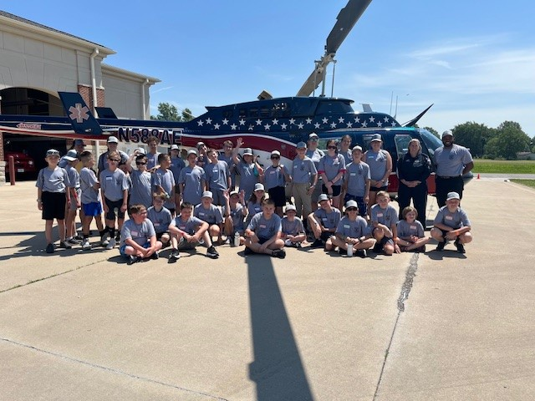
Classic Towing & Auto Body
Ray’s Automotive
Peace by Piece Co.
Rotary Club of Swansea
Country Companies – Corey Stelling
Trustee Jeff Parker
Swansea FD Civic Association
Swansea FD Ladies’ Auxiliary
The Sweet Side Ice Cream Truck

- Chief Matt Blomberg
Evidence
2024 was a year of changes for the evidence department at the Swansea Police Department. Officer Tutterow stepped away from managing the department after many years of handling oversight of the evidence storage duties. We thank Officer Tutterow for his dedication to the department. Detective Sergeant Gary Reuter now serves as the supervisor in this unit of the police department. Civilian Evidence Manager Nickolas Thouvenot runs the day-to-day operations and management of all evidence responsibilities.
Also, in 2024, evidence is now being used in a new database that allows for all evidence to be barcoded and organized more efficiently than ever before. This change allows officers to spend less time at the desk doing paperwork and more time out on the road serving the village. It also makes the evidence easier to handle at the Belleville Forensic Crime Lab and streamlines any submissions we make to the lab, making their job more efficient as well.
This barcoding also allowed us to organize our evidence storage internally as well. Now, locating and transferring evidence to where it needs to go is easier than before. Due to the tremendous work of our officers and detectives in 2024, we had a lot of evidence seized and recovered this year, including numerous illegal firearms, drugs, and stolen merchandise.
2025 will continue to see internal improvements to make sure our staff can continue to process and store evidence to the best of our abilities!

- Evidence Manager Nick Thouvenot
New Equipment
In 2024, the Swansea Police Department purchased 3 new squad cars to replace aging vehicles following our fleet maintenance schedule. Our long overdue remodel for the officer locker rooms was completed in the fall. This project provided new lockers for officers with the capability to charge their many work devices in a single location while off-duty. It also incorporated an HVAC system to help reduce moisture relating to wet uniforms, footwear, and outerwear. An aging air conditioning unit on our roof failed and was replaced by a more efficient model.
With grant funding through the State of Illinois, we were able to replace all of the body-worn cameras for our patrol officers due to battery degradation issues. Additionally, we replaced the lithium batteries for our portable radios for the same reason. We reorganized and streamlined our IT hub at the station to improve cooling, efficiency, and longevity.
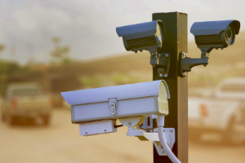
The police department expanded its network of automated license plate readers within the Village. These systems assist with traffic crash investigations as well as criminal investigations of stolen vehicles, fleeing vehicles, theft cases, and much more.
Lastly, we replaced our telephone recording system to provide better recordkeeping and service relating to our interactions with the public.
- Chief Matt Blomberg
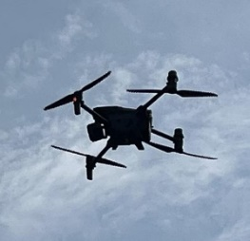
Drone Team
The Swansea Police Department uses state-of-the-art drone technology in missing persons, photographing serious traffic crash scenes, or locating violent individuals. While relatively new, the police department used the drone in several missions this past year, proving to be a very valuable asset to the citizens of Swansea and the surrounding communities. The department has five FAA Part 107 Small Unmanned Aircraft Systems (Drone) operators: Deputy Chief Keith Howard, Officer Justin Schutzbach, Detective Alex Wilken, Officer Seth Belford, and Officer Claire Avila.

For further information regarding our drone program, please visit our website for frequently asked questions:
https://www.swanseail.org/2352/Drone-Program

We would like to thank Hero Fund USA, Inc. for their contribution to obtaining this state-of-the-art technology that will help not only the citizens of Swansea but many local communities as well.
- DC Keith Howard

Departmental Training
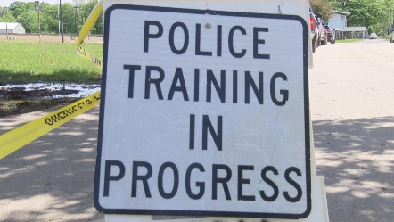
The Swansea Police Department continues to prioritize its officers receiving numerous trainings and continued education throughout the year. In 2024, officers in the department took part in a variety of training that far exceeds the minimum statutory requirements required by the Illinois Law Enforcement Training and Standards Board, Illinois Law (including the SAFE-T Act), recommendations from the Illinois Chiefs of Police Association, and recommendations from the International Association of Chiefs of Police. This year, officers continued with more online training to maximize the training each officer receives annually. This year, training increased by 211 hours more than last year.

The Swansea Police Department fully complies with the minimum standards determined by the
State of Illinois. In 2024, officers completed 1,564.25 hours of documented training. The average training time per officer equated to 68 hours per officer. The officers attended eighty-three different classes throughout the year. The following is a list of classes officers attended:

MILO Range UOF 1-2 Officers, Business Email Compromise, Stop the Bleed, Mental Health Awareness Refresher, Firearms Restraining Order Act, Taser 7, ILETSB- CIT, ILETSB-SRO, High Risk Traffic Stops, High Risk Traffic Stops (HRVS), ITOA - High Risk Traffic Stops Instructor, Emergency Vehicle Operations Course – Police, LTFA Initial, LTFA Recertification, Laws of Arrest, Review of UOF Laws, ARIDE, Detective Boot Camp, Basic Crime Scene Processing, Developing Women Leaders, Adult CPR/AED, Child CPR and First Aid, Officer Stress Management, Trauma Informed Response to Sexual Assault/Abuse Refresher, Emergency Medical Response, Advanced Tactical Emergency Casualty Care for Patrol Officers, Bridging the Gap, BAO Certification, Crisis Intervention and Disturbance Calls, Security and Privacy-General, SFST-Refresher, Overdose Reversal and Severe Trauma Training, Juvenile Law and Processing, Basic Patrol Rifle, Advanced Patrol Rifle, Proactive Patrol Tactics & Terrorism Intelligence Gathering, Digital Threat Assessment, The Winning Mind, Educate, Evade, Escape, Engage (4 E's), Basic Instructor Development, Constitutional Authority, Magnet AXIOM - 2023 Updates and Additions, Mobile Forensics Images - Getting the Right Data, Wire Transfer Fraud, Sexual Deviant Killers, Major Case Squad 8 hr Homicide Investigation, Crime Scene Investigation-Refresher, Ethics, Illinois Human Rights Act, Cultural Competency, Patrol Procedures, Interview and Interrogation-Refresher, A Review of Epinephrine Auto-Injector Use, Service Calls Refresher, Fundamentals of Report Writing-Refresher, Bulletproof Report Writing, Leader Armor, Leadership for a Lifetime: How the Past Prepares Us for the Future, Peer Support for 1st Responders, Sexual Assault Initial Responder & Investigator Instructor Training, Social Media and Online Investigations, Background Investigations, Simunition Instructor, Virtra Human Factors in Force Encounters, Sig Advanced Pistol Instructor, Taser Instructor, Windham Weaponry AR-15/M-16 Armorer's Course, Rapid Response/Active Shooter Instructor Course, ITOA - High Risk Traffic Stops Instructor, Illinois Use of Force Guidelines, Training Research, Updates & Protocols, UAS - Drone Pilot, Juvenile Officer certification, ILACP- Rethinking Responses to Common Calls for Service, Freedom of Information (FOIA) Law Review & Update 2024, Leadership in Law Enforcement: " The Narrow Road", Policing in 2024, ACP - Strengthening Targeted Violence and Terrorism Prevention In IL, ACP - Safe-T Act: Law Enforcement's Responsibility & Role In ILETS, ILACP - Embracing the Truth: A Wellness Foundation, ILACP - 2024 Legal Update, FBI NAA Re-Trainer Event, ILACP - Recruit, Develop, & Retain the Next Generation of Officers, Modern Homicide Investigations, ILACP - Understanding the Eight Levels of Supervisory Engagement

Most of the training was from the Southwestern Illinois Law Enforcement Commission, MTU
#14. Some of the training was conducted at conferences and online by the Illinois Law Enforcement Training and Standards Board Executive Institute or the Southwestern Illinois Law Enforcement Commission. Several Swansea Officers are certified instructors and instruct several of the above-mentioned training in-house. The Swansea Police Department is dedicated to seeing that our officers exceed the minimum standards set by the State of Illinois. Your Swansea Officers volunteer to attend much of this training to ensure the highest quality of service to the community.

- Sgt Braxton Kociemba

Active Shooter Training
SPD trainers and personnel provided guidance and instruction to our school districts in responding to active violence incidents. SFD personnel assisted as safety officers during the exercises. Under the direction of School Resource Officer Jones, the staff conducted several instructional presentations and drills at our schools in compliance with the 4E Response Program from TierOne Tactical Solutions. 4E Information can be found at: https://www.tieronetacticalsolutions.com/
- Chief Matthew Blomberg

Charitable Efforts
The 2024 Special Olympics for the Swansea Police Department was a good year. Sergeants Kemper-Damm and Huff and Officer Proffitt signed up for the Collinsville Polar Plunge. Inclement weather, unfortunately, canceled the event. Officers Avila and Proffitt participated in the Carlyle Polar Plunge with a balmy water temperature of 34 degrees. Among all the officers who participated, we raised $1,659.33 for the Special Olympics.
In June, our department had a wonderful turnout for the Law Enforcement Torch Run. Fifteen participants, which included officers, staff, and/or spouses/children, jogged from the Swansea Police Department to Huck’s Fuel Stop (3.2 miles), where we passed the torch to the Fairview Heights Police Department.
T-shirt days at Big R in November raised $550.00 for the Special Olympics. In total, the Swansea Police raised $2,752.91 for this worthy cause.
We are looking forward to another successful charity campaign in 2025!
- Officer Clayton Proffitt


Internship Program
The Swansea Police Department continues to partner with multiple institutions of higher learning to provide college interns with the opportunity to experience the everyday work life of police officers. In cooperation with their college or university, students spend significant time with all police department personnel, learning about law enforcement and the criminal justice system. Interns have the opportunity to ride with patrol officers, observe detectives work cases, learn from drug investigators, accompany the School Resource Officer in our schools, and attend training and operations with the St. Clair County Special Response Team. In 2024, we welcomed one of our own as an intern. Andrew Simburger, son of retired Swansea Sergeant Leo Simburger, completed his internship requirement for Slippery Rock University with us. Andrew is a U.S. Marine Corps veteran striving to continue his public service in law enforcement.
- Chief Matt Blomberg

Social Media
Swansea PD uses Facebook as a primary source for social media interactions with the community. SPD has an amazing social media following as well as fantastic support from our citizens and surrounding communities. Facebook is a great way to inform the community about upcoming events, BOLOs, arrests, important information, lost/found animals, Hyper-Reach alerts, and other information necessary for the well-being of the village.
In 2024, the Swansea Police Department's Facebook page generated the following:
Total posts: 87
Reach: 246,600
Views: 287,400
Reactions: 22,000
Visits: 72,400
Comments: 1,500
Shares: 3,500
Followers: 15,505

We want to thank every one of our followers for providing us with another means to communicate with them.

Follow us at https://www.facebook.com/swanseapolice/

Swansea PD also has Instagram. Follow us at: https://www.instagram.com/swanseapoliceillinois/


Swansea PD can be found on Twitter. Follow us at @SwanseaPDIL

- Chief Matt Blomberg

Website and Police Blotter
The Swansea Police Department maintains a link on the Village website to our daily blotter containing calls for service and officer activity. To protect victims of crimes, no exact addresses are used. The purpose of the Swansea Police Blotter is to better inform our citizens of what is occurring in their neighborhoods. The blotter can be found at: https://www.swanseail.org/2255/Police-Blotter.
- Civilian Administrative Supervisor, Ashley J. Robbins


Hyper-Reach
The Swansea Police Department encourages all residents to sign up for the Hyper-Reach Emergency Notification Application. This application is utilized for many different events ranging from non-emergency community events, missing persons, emergency road closures, etc. We also use this system to send out weather alerts throughout the Village. In 2024, the police department disseminated 4 Hyper-Reach notifications, one for a young child found wandering alone in frigid temperatures, another to inform the community of the reunification of the child and family, a third to invite citizens to a community event, and lastly another to warn community members of gunfire that would be happening for a Veteran’s Day Ceremony.
To register for the Hyper-Reach system please go to https://signup.hyper-reach.com/hyper_reach/sign_up_page_2/?id=111144.
- Civilian Administrative Supervisor, Ashley J. Robbins

Swansea Cultural Working Group
The Swansea Police established our Cultural Working Group to bring law enforcement executives and diversified members of our community together to strengthen existing relationships and forge strong new ones.
This group of police, government, and community members meet every few months to facilitate professional conversations relating to relevant topics associated with community policing and events, legislative issues and concerns, policy review, and partnership building.
This amazing group of people donates their time to provide the Swansea Police Department with invaluable insight and advice as to how this agency can best serve our community’s needs and surpass their expectations. We are thrilled to announce Francine Nicholson, president of the NAACP Metro East Chapter, has joined our group. The other members include High Mount School Superintendent Dr. Beth Horner, Wolf Branch School Superintendent Dr. Nicole Sanderson, Village Trustee Cary Lewis V, business owner Brandon Crisp, current Deputy Chief Keith Howard, Village Administrator Ben Schloesser, Mayor Michael Leopold, Swansea Police Commissioner Anthony Byrd, Pastor Fowler from Life Church. Thank you to our members for their continuing support, collaboration, and guidance as we strive to serve our community the best we can!

- Chief Matt Blomberg

Index Crimes
Index crimes are those crimes that must be reported to the FBI. There are specific guidelines on how they are to be reported and what category of crime falls under a section. The FBI uses them to identify nationwide patterns of crimes.
https://bjs.ojp.gov/national-incident-based-reporting-system-nibrs

The following pages include the crime data submitted to the FBI as required as well as a summary report of all calls for service to the Swansea Police Department in 2024.
Offense Summary Report
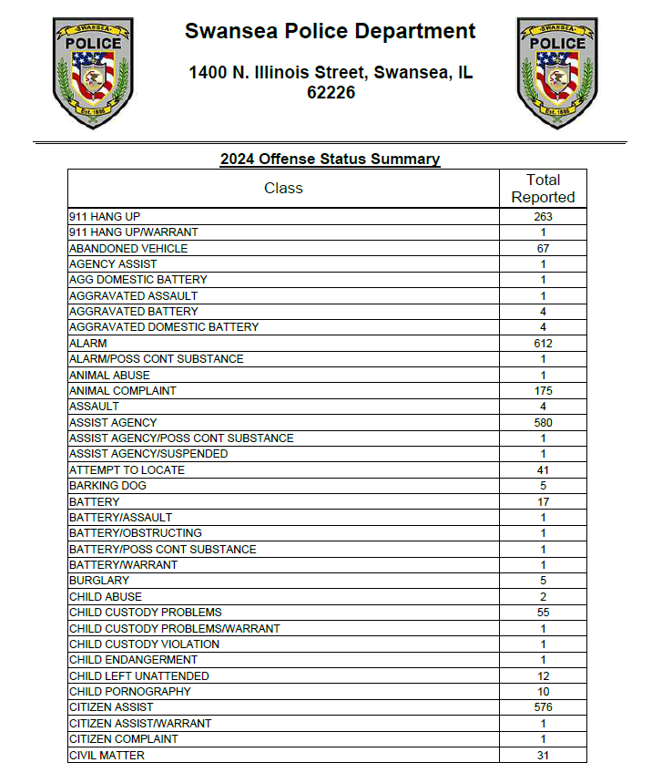
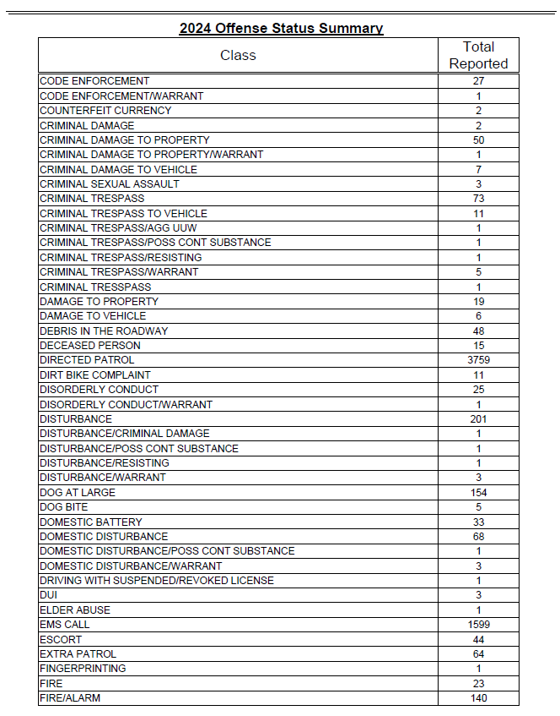
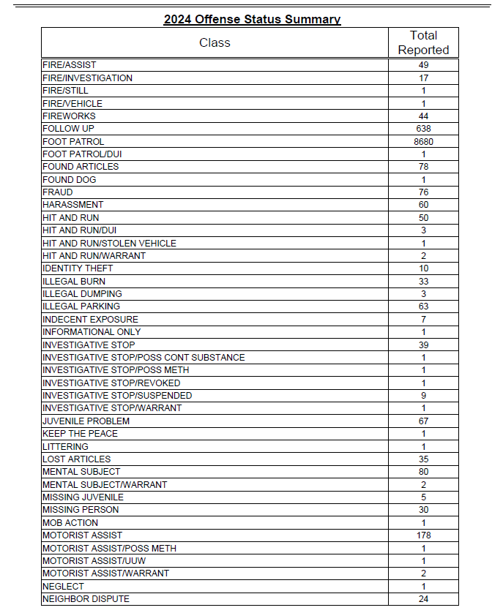
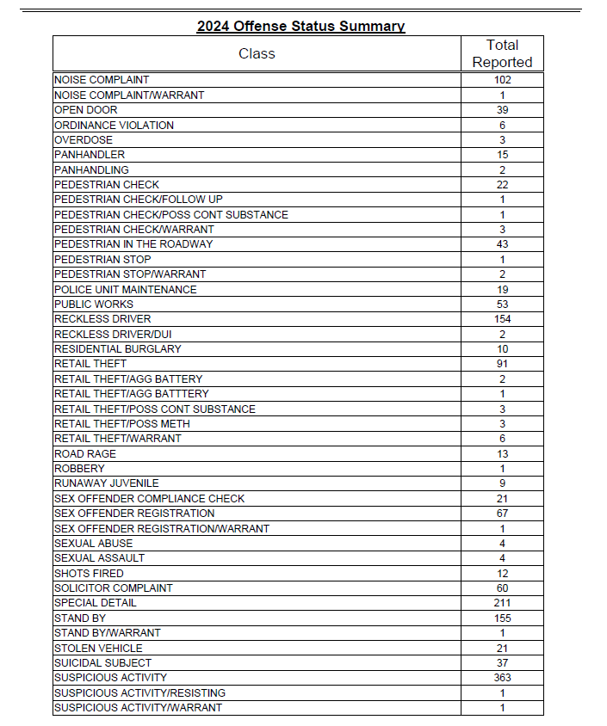
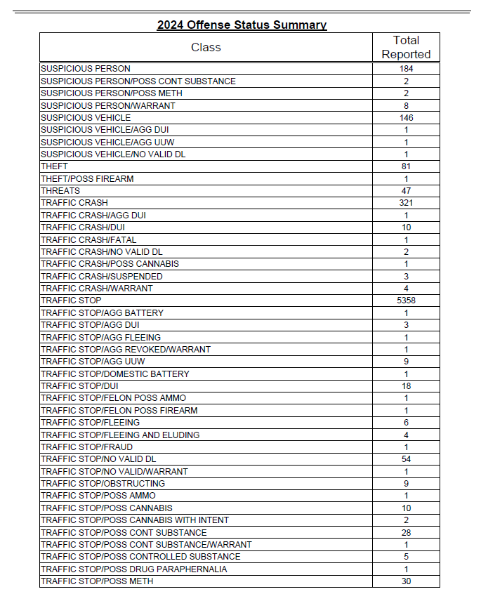
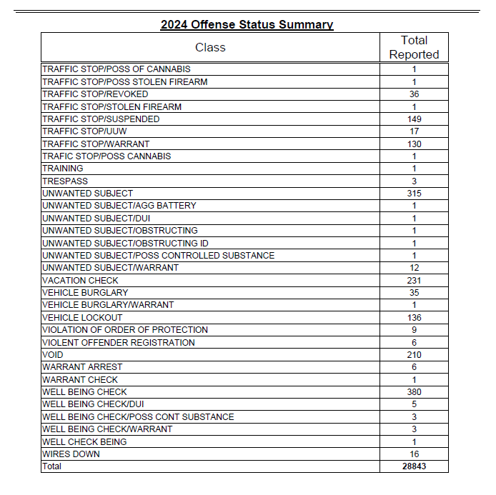
A digital copy of this report can be found on the Village website:
https://www.swanseail.org/2310/Year-End-Report

